IT226 Biotechnology Lab 1

Fall 2016

Reflection 1

Due Thursday, September 15

1. How would you describe the process of research?
2. Would you describe what you have done thus far in class as research? Why or Why not?
3. How would you describe the project you are working on this semester to someone outside of class in 2-3 sentences?
4. If students isolate and sequence the DNA of phages from different sites nationwide, what kinds of research questions can be answered with the data they collect, assuming they record all the requested sampling information?
   1. *Note: In lab, be sure to include all of your sample data in your lab notebook, including a picture of the sample site and your GPS coordinates, so your data can contribute to the national initiative and help address broad research questions beyond Purdue*
5. What did you accomplish this week? Your answer should include a summary of your findings.
   1. Reflect on the meaning and/or implications of your findings for the work that you have done in lab thus far. Refer to the data or evidence that you have to support any claims that you make. Or, more specifically, did you find a plaque? If so, what were the characteristics of that plaque? Do you think it is a lytic or a temperate phage? What data/evidence do you have to support your conclusions?
   2. *Note: During lab, make sure you take a picture and document both positive and negative results and label your evidence clearly in your notebook. You need to document the outcomes from each sample you process-----remember----if you don’t document it, it didn’t happen.*
6. What issues or challenges did you face this week?
7. What are your goals and plans for the upcoming week?
8. State 1-2 questions that you have about the results, the activities/experiments, and/or the research project.
9. What is the difference between a lytic phage and a temperate phage?
10. Can you tell if a phage is likely to be lytic or temperate based upon the morphology of the plaque? Looking at the figure below, can you make a guess about which phage (left or right plate) is likely to be lytic and which is likely to be temperate? Provide a rationale to support your answer.

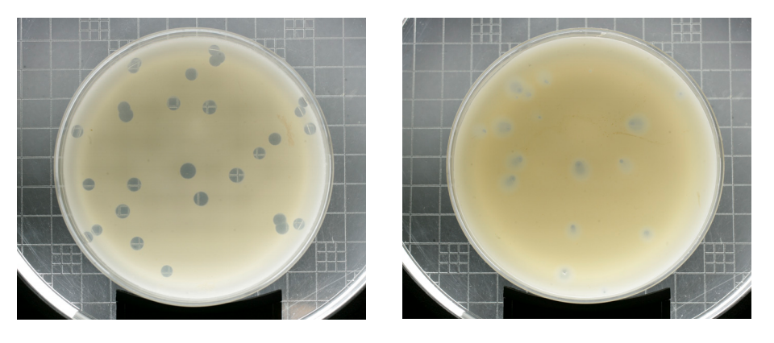

1. The filters you are using in lab to process samples are “0.22 μm.” What’s the significance of “0.22 μm” relative to the things that might be present in the supernatants?